Data warehouse
A data warehouse is a centralized repository for structured data that has been cleaned, transform and organized for querying and reporting.
Example : Tera data , snowflake, Amazon redshift etc.

Data Lake
Data lake is a large scale storage repositories for all format of the data ie structured, semi-structured as well as unstructured
Examples : Amazon S3, Azure data lake , Hadoop HDFS

A data lake house : is a hybrid architecture that combines the best of data warehouse and data lake.

Databrick lakehouse, Delta in S3 , Apache iceberg on AWS.

Azure provided one of the module ie DataBrick notebook. This notebook provide us to do programming for spark using any language like Java, python, R or scala etc. it provide GUI base to do coding.

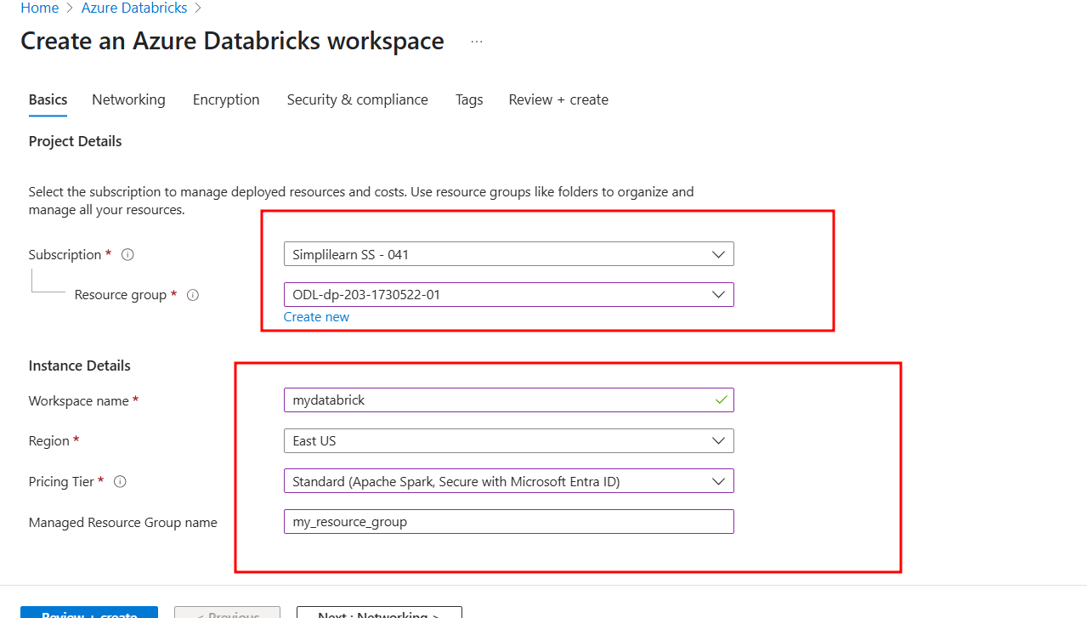

Delta notebook simple example

